Walkthrough Atom RPG
On Dec 19, 2018 8:50 pm, by Deadpool
Create a character and you will find yourself in the first location. After a while, the main character is robbed. Take an army flask from stump. Go beyond the fence and search the crates. One of them will be locked. Cross the bridge. You will be at the new location after the video.

Otradnoe
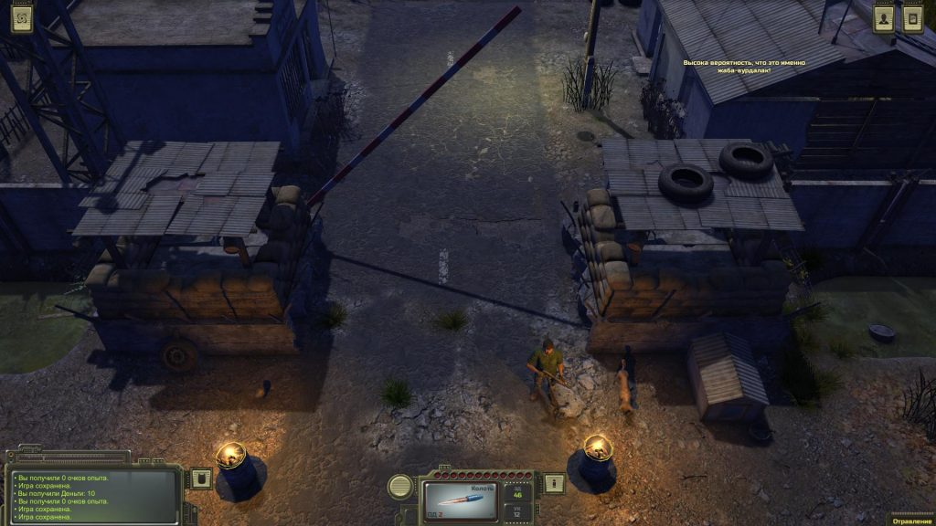
Go to the man at the gate and chat with him. His name is Jan. Talk to him and you will learn that expedition of General Morozov went in the direction of the bunker 317. You will have to look for him.
Also you need get him a bottle of cold beer. Earn some money or collect loot and go to the bartender and exchange the loot / rubles for a bottle of self-made beer (it costs 14 rubles). Give him a bottle to complete the quest. You will get 32 experience points and 3 rubles.
Follow the territory of the village. Enter the building on the left. You learn about the store. Now you have not money and loot. There are the general and his elderly guard in the building to the right. He is a Head of Otradnoe. Search bookcases to find a book with "Blatant slang" in one of them. Right-click on it, then select the icon “Use”. You unlock the skill "Criminal slang".
Go ahead and talk to the bartender in the tavern. He will ask for a service - bring a book from a merchant from Krasnoznamenny.
There are two huts near the bar: the old woman lives in one, the grandfather lives in the other. Chat with grandfather. He will ask to collect a crop of corn. Walk behind his house and collect five bushes of corn. There you can find a shovel.
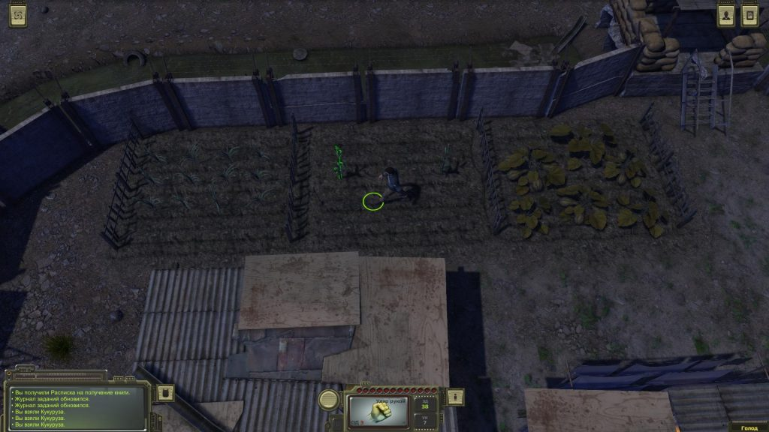
You can attack opponents using it (you need to equip) and dig graves on the side of Otradnoe. You can find the soap, wires, money, rusty knife or glass bottles do in the graves. Go back to grandfather and give him the harvest. Ask to look for something as a reward. He will find a hunting rifle. You will also get 32 ​​experience points as a reward.
You can meet the local home-makers in the large building on the left. He will ask to repair the pump of the water tower. Otradnoe were left without water. The mechanic disappeared somewhere. Agree to help. You can play dice with a bald man nearby. Go to the engine (located in the territory of Otradnoe, next to the water tower), move the cursor, hold down the LMB and select the action “Repair”. If it didn't work out, so you have to try again. Focus on the magazine in the lower left corner of the screen. You will get 105 experience points. Talk to the home-makers and ask for a reward. Also you get 50 rubles.
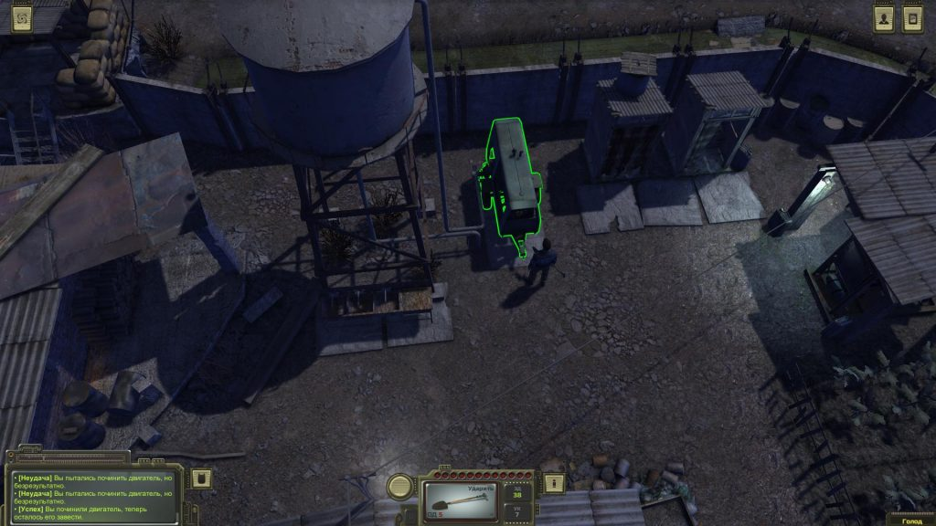
There are two types of enemies around Otradnoe: the mutant spiders, wasps and rats.
Return to the waitress named Katya from the tavern and talk to the girl. If you have communicated with the bartender before, you can say that he sent you to her. Talk and agree to taste the drink. As a reward, you will receive 32 experience points, +1 damage due to hunger, and 23 poison damage points. Talk to Katya again. You need to find five mushrooms - red mushrooms with white dots at the location around Otradnoe. Of course, you have to fight with monsters. Outside the city you can find a lonely house (not far from the entrance) and a man by the fire. You can play dice with him. And you can cook meal on the camp-fire.
Go in search of mushrooms:
- You will find the first on the left-down from the entrance to the city where Jan stands. Not far from the poisoned cloud.
- Move up the perimeter of the location and in its middle. You will find the second mushroom at the left edge.
- Outside of Otradnoe, there are large stones in the upper left, on the corner. Near them grows another mushroom.
- A fourth mushroom grows in the upper right corner, behind the large stones.
- Go down along the right edge of the location and you will find the fifth mushroom near the log.
Go back to Katya, give her the mushrooms and get 52 experience points. Ask Katya about Head of Otradnoe and get another 52 experience points. Also she gives a note with recommendations for Comrade Kovalev.
There is a lake at the top left of Otradnoe. Go around it and find the caches (at the edge of the map). Chat with the fisherman sitting next to you. He will ask to bring him bottle vodka! Return to the bartender and buy bottle vodka for 27 rubles. Go back to the fisherman, give him the drink and earn 21 experience points. Listen to the fisherman to get a new skill - Entomologist. Now you can collect organs from the corpses of monsters: from spiders - brains, from rats - meat, from wasps - paws. Also, if you kill a giant ant, you will get its salivary gland. Use it for fishing. Fish restores your health, and you can sell it for good money. In addition, you gradually restore the health points of the character on a fishing trip.
Go to Kovalev with a note received from Katya and talk to him. He will ask to find a rat in Otradnoe. Go to the deputy and talk with a bald man. He will give himself away. Go to Kovalev and say him that it is Grishka. For this you will receive 250 rubles (by default).
Agree to help him in the next task. Return to Grishka. He must go to the lonely hut behind Otradnoe. If you could convince him, then follow there too. For this you get 52 experience points. Save the game, before you start a conversation with Grishka! In one of the caches you could find a cartridge for a hunting rifle. Preload a gun and take it in hand. You can also equip a rusty knife found in a grave, or a shovel that.
Kill Grishka and search his corpse. Take the dice and Ace card. For this you get 60 experience points. Return to Kovalev to complete the task. Get a reward - 158 experience points and 350 rubles.
Kovalev will give the next quest, and ask to infiltrate the gang.

Pier
The location is located to the left of Otradnoe. Go there, go to the territory and find a fisherman, a fishing rod and other caches. The Cache is hidden under one of the two boats to the left of the fisherman.

Crossroads
Below Otradnoe you can find milk tanker. Go to the location "Crossroads", where you can search the trunk of a car and the corpse in the driver's seat.

Filling station fortress
Go down on the map and you will find a concrete stop. Enter the location. At this location you can chat with Kachan. If you killed Grishka, you can play dice with the soldier. He has a lot more money (see barter) than the Georgian from Otradnoe. So you can get rich here. The remaining characters will not be so friendly.

Place of accident
If you go down even lower, then you will find the place of the accident (broken car). Go there, you will find a tent with a grandfather on the left. You can buy a good dagger from him. There is a poisonous cloud in the upper left corner. Examine it to find cache under one of the stones.

Abandoned factory
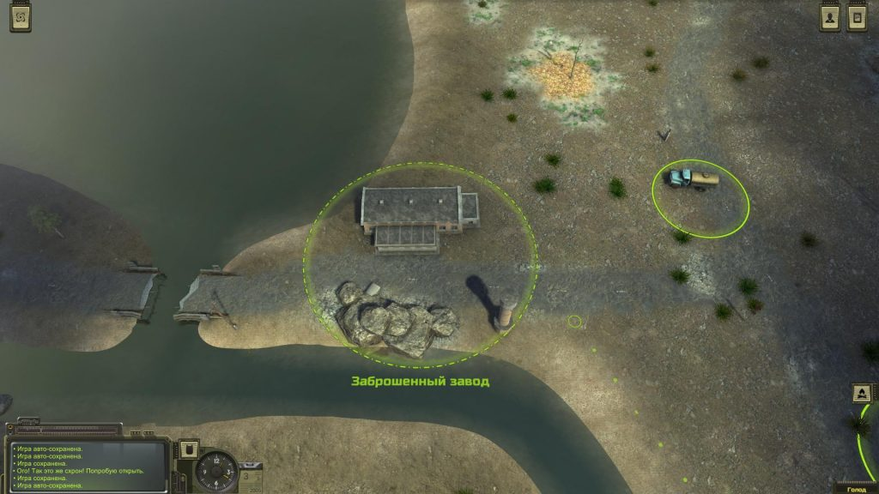
This location is down and to the left on the road from Otradnoe. You should get here on the instructions of Kovalev or by agreement with Grishka. We killed Grishka. Follow the road and show Ace card the guard at the entrance, so you can get inside. Now you need to chat with Dan.

Help wounded bandit
Enter the large warehouse where the bandits are. Two of them are guarding the grid. A little further, there is a wounded bandit in one of the rooms. His name is Leonid. Talk to him and offer help. Return to Otradnoe and talk to Dr. Mikoyan.

Search father of Dunya
There are two bandits at the exit. One of them is a girl disguised as a guy. You need to talk to her. She is Dunya and she will ask you him to find her father. Agree to help her. You will find father somewhere in the wasteland.
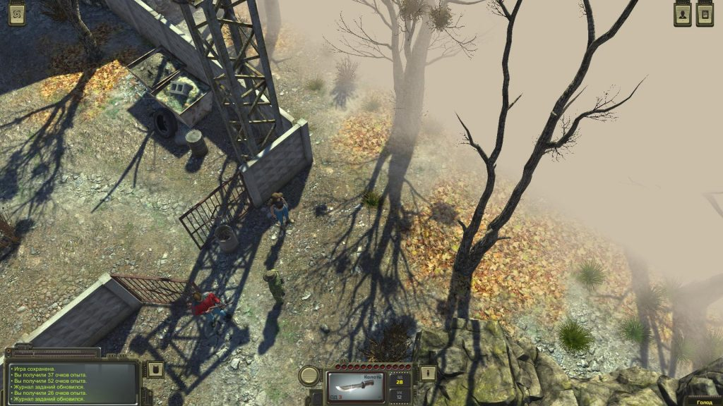

Check Dan and Shishak
It's time to talk to Dan. He is in a separate building. Talk to the man in the white suit.
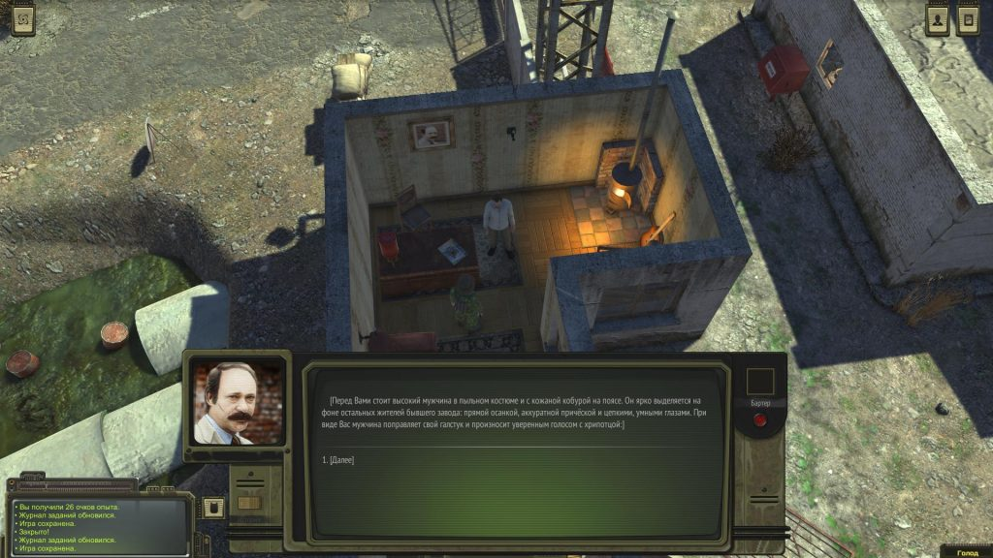
Go to the huge building with locked lattice on its instructions. There are two men left and right of it. The one to the right is the Shishak. Talk to him, go inside and again talk to Shishak. He give a pistol, try to shoot at a man. But the pistol is not loaded. However, you will pass the test of bandits.
Go back to Dan and he will ask you to go back to moonshiners. They have to pay money. Talk to them or to kill them.

Salvation mechanic Steblev
Return to Kovalev in Otradnoye and tell about the prisoner. He will ask him to save. He is the mechanic Steblev. Agree to help, go back to the factory and pay Dan 500 rubles (you can bargain). Kovalev give you money and experience points at the end of the quest.

Search for three brothers
If you didn't shoot a prisoner, but beat him, then you will need to find three brothers. You will need to visit the location "Maiden spring farm", which is located to the left of Drunken Lair, near the mountain. Go there. There is a grave named Masha in the lower left part of the location there. Talk to the man on the farm and ask him about the grave. Tell him you knew the three bandits. They raped the man's daughter.
Go back to Dan and report on everything. If you tell Dan that the villagers know that he sent the three bandits, then Dan will send people to kill everyone. If you say that the residents do not know about Dan, he will not pursue them, and you will get 700 rubles.

Search for accomplices of Shyshak
After you deal with the elections in Otradnoe and help Dan in the fight against Shyshak, leave the location and return to it again. Talk to Dan, you get the reward and agree to help with the next task. It will be necessary to find accomplices of Shyshak in Krasnoznamenny or Peregon.
Go in Krasnoznamenny and go to the brothel. Left, there is a lair of bandits. Enter inside, tell name Shishak. Talk to them. Gosha will give you three tasks - you will need to repay debts.

Mafia debtors (easy 15 000 rubles)
Go to the casino. Chat with the man sitting at the slot machine. Convince him and then get 5,000 rubles.
Go to the Chamber of Commerce in the center and find the girl (Katerina Mavrova) in the gray jacket. Convince her and get 7,000 rubles.
Return to Krasnoznamenny, visit the power plant. You need Semeon Lapushkin. Talk to the man during the day. Convince him and you get 3000 rubles.
There are two options:
- Take the money to the bandits to get 500 experience points, 1,500 rubles and the opportunity to go to the leader.
- You can keep 15,000 rubles for yourself. Three days later, gangsters will kill the debtors. The quest will not be completed, but you will go to the leader.

Containers
Talk to the leader of the gangsters in Krasnoznamenny to get this task. You can find the location "Containers" in the eastern part of the map, on the bank of the river.
Go there and start the dialogue. You cannot agree here. It is unrealistic, but you can fight first. There are 11 opponents here. Kill them all, and then return to Dan to complete the task. He is waiting at the plant. For this you will receive 3000 rubles and a 1000 more, if you pass the test communication. Quest chain of bandits from the Plant is completed.
Return to Zlatoust in Krasnoznemenny and say that you killed the gang. For this you will get 100 experience points and 500 rubles.

+ Caravanserai
Go to the bunker of the Chamber of Commerce in Krasnoznemenny immediately after the completion of the elections in Otradnoe. Talk to Ivan Ivanovich (in the room next to the man who was responsible for the supply of coal). He gives a new quest related to a visit to the Caravanserai in Mountain Pass Woes. You will need to pay a truck driver from Fogelevka to get to the new global map.
Go in the local tavern and talk to Mahmudov, he is sitting at the table on the right. If you return the cook Arsen (we described in detail below) and say about Krasnoznamenny. The commandant will agree to recognize the authority of the city. Return to Ivan Ivanovich in the bunker of the Chamber of Commerce, report him. You will get 2000 rubles and supplies.

Drunken lair
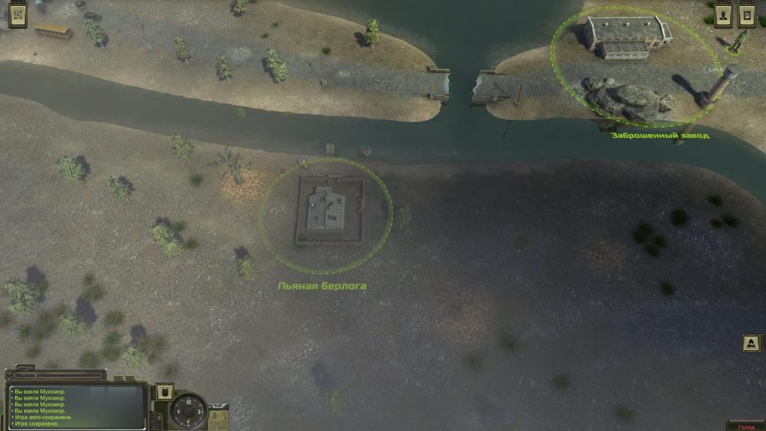
Go inside the house and talk to Petrovich. Select the “Destroy Moonshine” option. But you don’t break it. Select the option “Take a swing with a stool, but stop on time”. Petrovich will frighten, and he will agree to pay to the bandits. Return to Dan and report him about the mission. You get 420 experience points and 700 rubles.
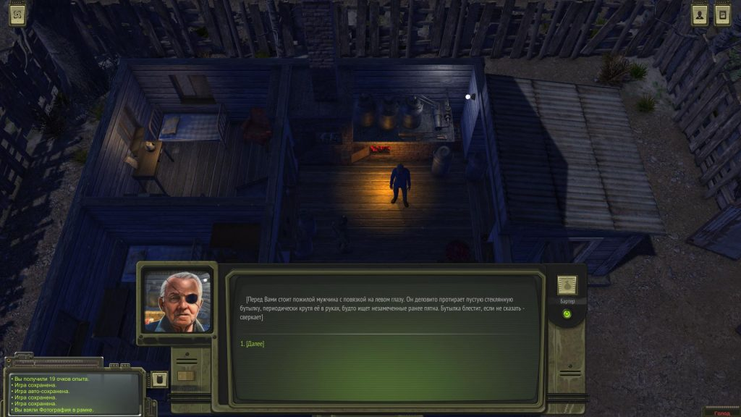

Friend of the moonshiners
Talk to leader of the moonshiner. He says you about his missing friend. Go in search of him in Roaring forest. Find a tent with a grandfather and a woman. You take the quest associated with the destruction of wolves. Grandfather - the same companion of moonshiners.

Circus (Quarrel of Barbara and Yana)
Below "Drunk Den" you can find a huge plane. Go to the location. There, you can talk to many characters. Find the prophetess Barbara next to the plane. Talk to her. She had a fight with Yana. Go left around the circus tent. Find Yana.
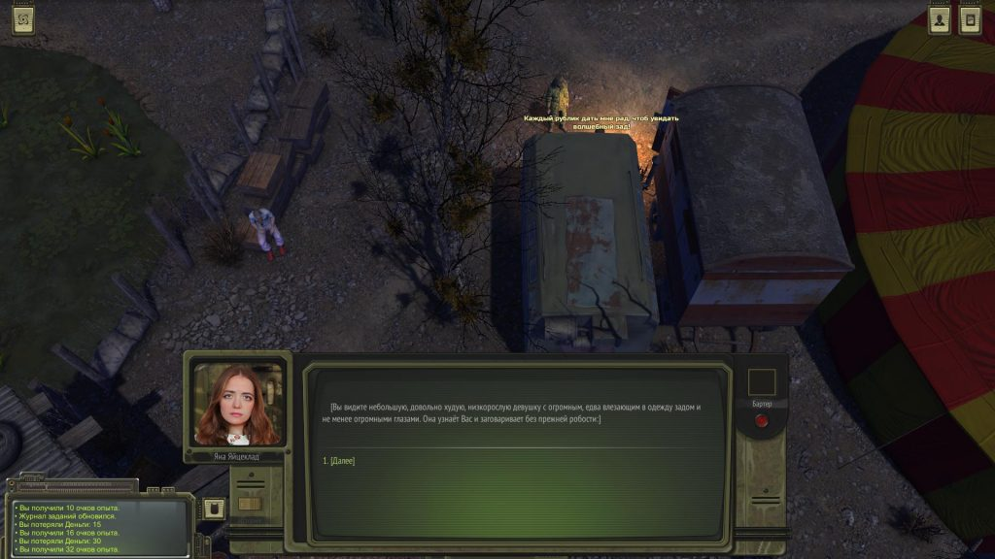
Chat with her. She will say that Ivan reported this incident and complained about Barbara. Ivan is to the left - the character has a beak on its nose. Talk to him, and then tell everything to Yana and Barbara. Quest will be completed.

Rat king
You can find Nicholai on one of the towers to the north of the plane (around the perimeter of the circus). Unlike other guards, he is not dressed up in a clown costume. Talk to him and he will ask for help - to deal with the Rat King. Go south from the plane (if you look at the map through the M key) and kill ten rats. The Rat King will appear after their destruction. Talk to him, kill and return to Nicholai for the reward.
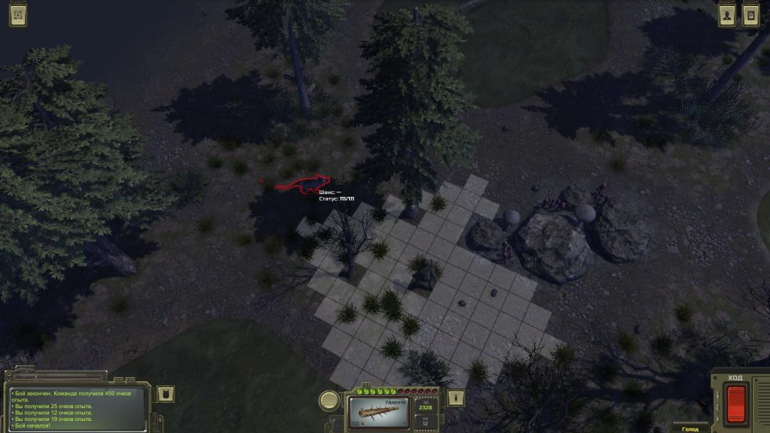

Roaring forest
The leader of bandits Dan (from an abandoned factory) will send you to this forest.
Go to the location and find the transition point to the dungeon in the upper left corner. There will be a pit and a fallen tree. You can go down without a rope, but in this case, you take damage - about 40 units. If you find a rope (buy it or pick it up somewhere), then there will be no damage.
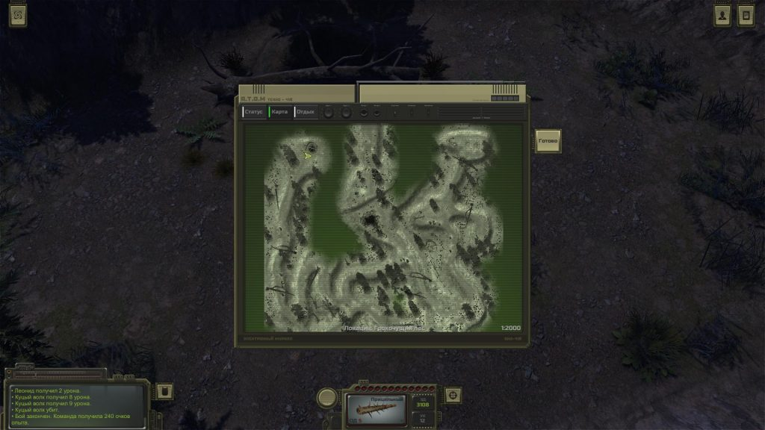
Note. You can find a blocked passage in another part of the location (in the lower right corner). Deal with the gangster (you can try to convince him), then go to the edge of the fly agarics. In the center, there is a cache.
Go down, you will find mutants. Kill them all, including the huge Digger at the end of the tunnel. Return to Dan and talk about what you saw. For this you will receive 1260 experience points and 1300 rubles.
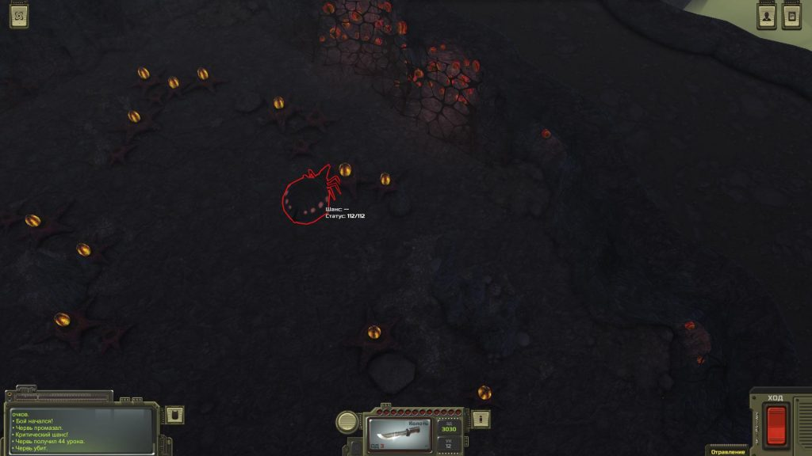

Wolf hunt
You can take this task from Valery in the location of the Roaring forest. He will ask to kill the wolves. You will find them to the right of the tent. If you wait any longer, the elderly will be killed. Return and report on the completion of the mission.
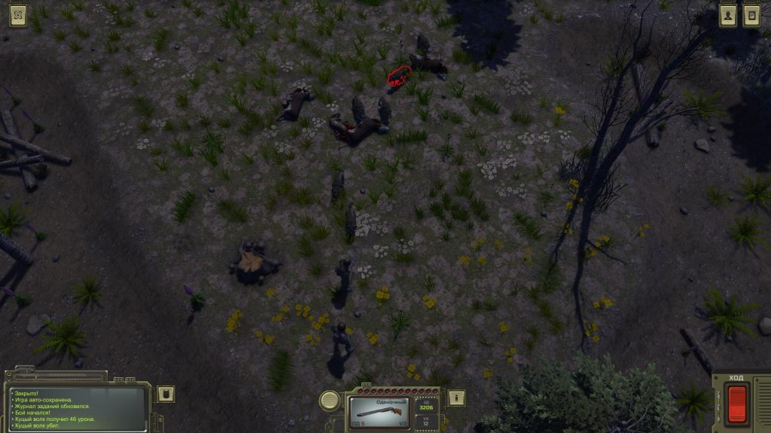

Krasnoznamenny
It is time to visit this city. It is located lower than the abandoned factory and to the right of the map. Open the global map, click on M and see the city.

The supply of coal
Go into its territory and follow to the object from the left side. This is a power station. Talk to the chief electrician (he is the only one here) and learn about the interruptions in the supply of coal from Peregon. Agree to help and ask about the award. He promises to give 700 rubles.
Alexander Sablin is in the bunker of the Trade House. Go in Krasnoznamenny, and then go to its upper part (through the green area with dashed lines). Go up and on the square with the statue you will find the entrance. Enter inside and take the elevator to the left. Talk to the guard. That will agree to pass you in chamber if you pay 7000 rubles. You can bargain.
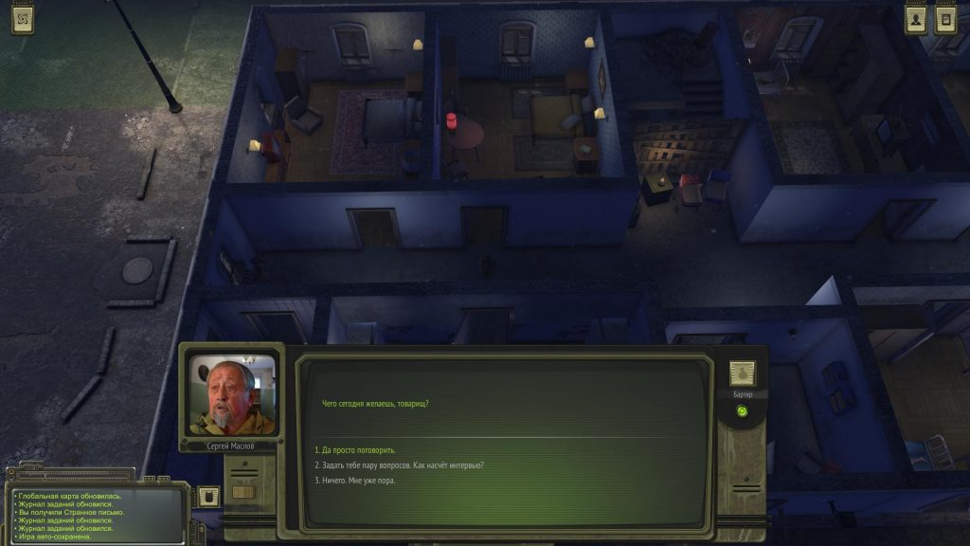
Go down. There are rooms on the left side of the bunker. Sablin is sitting in one of them. Chat with him, he will send to Mambetov at the location Peregon. He is responsible for the charge of coal.
Go to Peregon, enter the tent city, climb onto the barge and enter inside it through the door on the right. You find Mambetov in the room with two girls and a man on a bed. Talk to him. He will say that you need to talk with the driver of the truck.
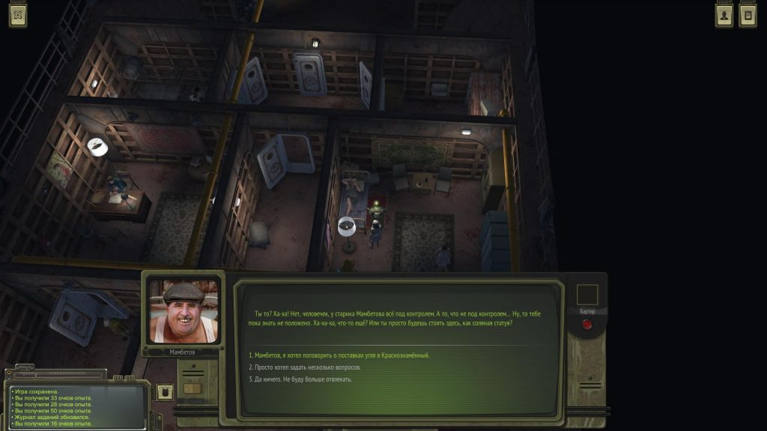
Go outside and talk to the man. Go in Krasnoznamenny, but the marauders will stop you. Convince them to retreat; otherwise you have to fight together against enemies. Kill everyone, collect loot and interact with the truck. Report Sablin. You get 126 experience points and 700 rubles from him.
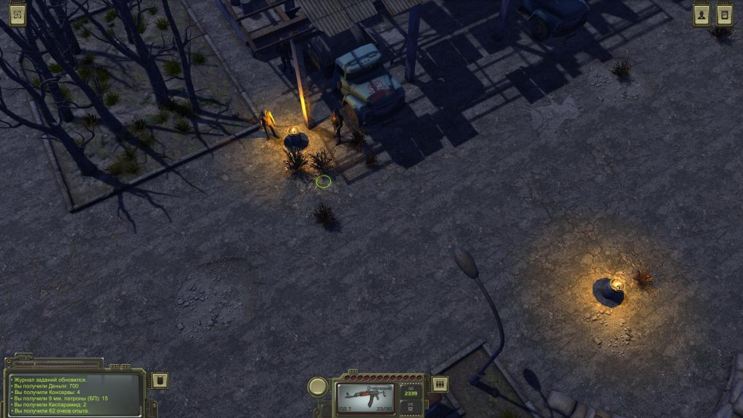

Attack on Otradnoe
Enter the tavern on the right along the main road (Krasnoznamenny) and talk to the man sitting at the nearest table. He will talk about the attack on Otradnoe. Agree to help. At the location of the "Filling station fortress" is a sniper Ludmila, and on the territory of the "Fortress of the Border Guard" you need to find Major Pronin. Smirnov Konstantin Arkadyevich, a saboteur, is near Otradnoe.
Go to the location Filling station fortress, help the military with the gangsters and then talk to the only girl. This is Ludmila. You can convince her, or you can kill wolves. After that, Ludmila will agree.
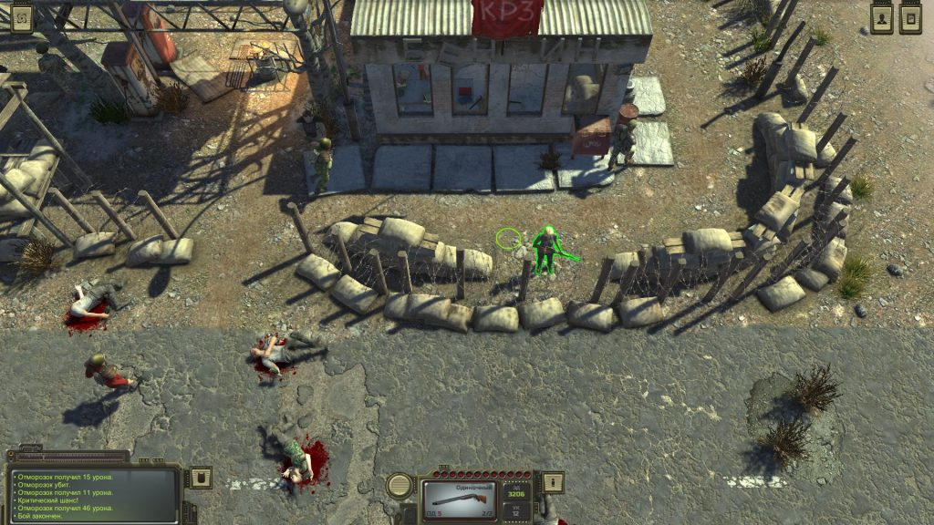
Go to Otradnoe, go to the bar. There is saboteur Smirnov in a military earflap at one of the tables. Chat with him.
Visit the Border guards fortress and talk to a man in the clothes of a paratrooper. Convince him and return in Krasnoznamenny and chat with the man. He will give you 400 rubles. If you pass the test communication, you will get another 200.
Agree to take part in the attack on the bandits and learn about the location "End of the line." We described further actions below in our walkthrough.

How to get a partner Fidel?
In the same tavern you can chat with the bartender. Give him the password, then talk in the back, and Fidel will agree to help you. So you get your first companion!

Help sectarian
Above the bar you will see the sectarian Davi Christus. Talk to her. Another sect will ask to follow Davi. She went to Otradnoe.
Go to Otradnoe and go to Davy (near the entrance with other sectarians). Talk to her. She says the next stop is Drunken Lair. Chat with Davi on location, then return to the sectarian in the suburb Krasnoznamenny and complete the quest. In addition to experience points, you can choose first-aid kits or rubles.
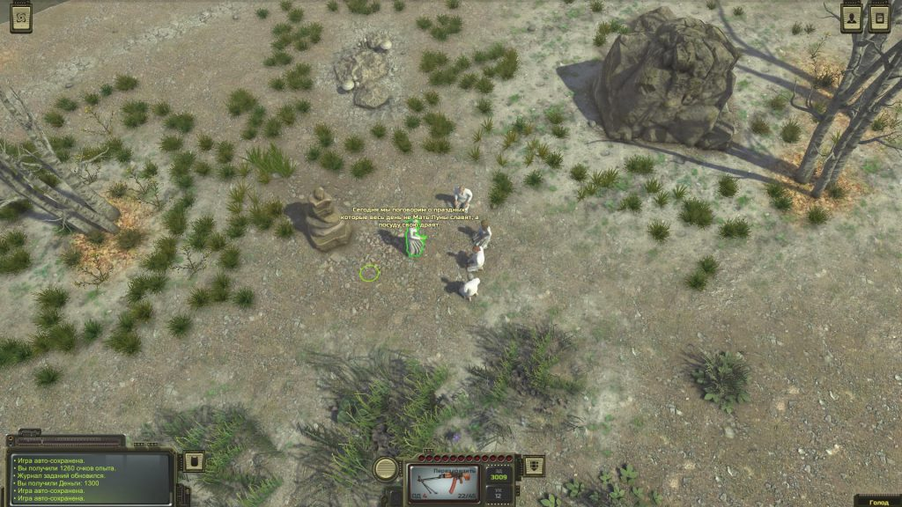

Get rid of Davi Christus
After the previous task, the sectarian will ask you to eliminate Davi and all her followers who are in the casino in Krasnoznamenny. Go to the casino and talk to Davi. You can report that sectarians are trying to get rid of her. Ideally, you need to give her a few compliments, get tested, and then go to the brothel and agree with the bouncers. Pay him 100 or 50 rubles and tell Davi about it. In the room, you can kill her or tell the truth about the threat. In the second case, Davi escaped from Krasnoznamenny. You will receive 50 or 100 rubles as a reward from the sectarian.

Help gypsy fortuneteller
There is a hut of gypsy near the entrance in Krasnoznamenny. Chat with her and pay 20 rubles for fortune-telling. She tells about the owner of the mummy Lenin, who lives in the city.
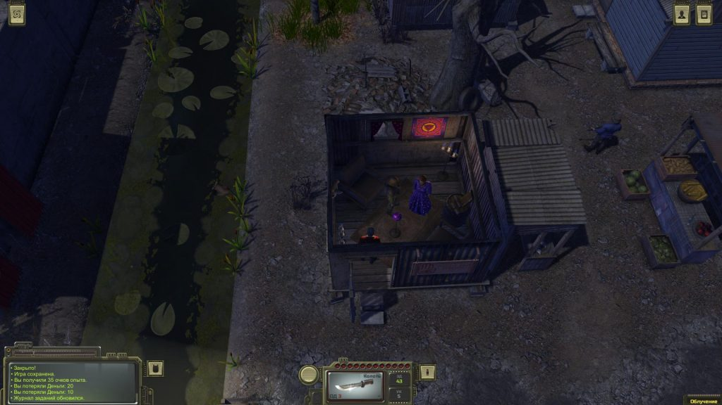
Go outside and move across the road diagonally to the house. There is a large red banner with Soviet symbols. In the afternoon, a red-haired bearded man will stand here. You can talk to him, pay 15 rubles and look at Lenin's mummy. Also you can break the door to the house at night. Try again until the door opens. Come inside and see how the man plays with the double of Lenin in the cards. You can lie to the fortuneteller, and you can tell everything. You will earn 105 experience points and 200 rubles.
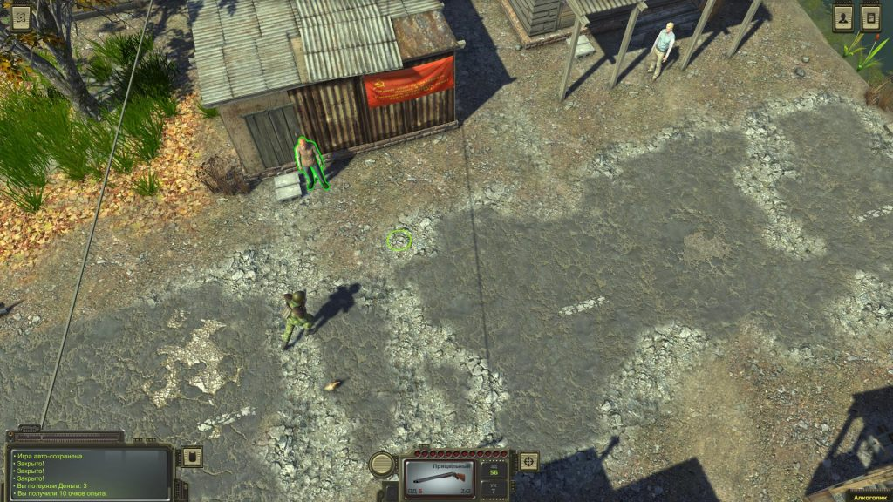

Help Gubtsov
Go to the territory of Krasnoznamenny. You have to pay the guard 1000 rubles or convince to reduce this amount by communication or barter. Once in the city, go to the right and enter the hotel (long building). The writer Gubtsov is sitting in the kitchen. Chat with him. He will ask for help: you need to talk to the editor Vladislav Zhirenko, who is also in the hotel.
Go to the upper part of the city (through the aisle) and find the hotel on the left side. Go into it. You can pay 50 rubles for the rest and breakfast. There is the editor (Vladislav Zhirenko) in the second room from left to right. Chat with him. Talk to him about uniqueness of Gubtsov’s work, he will agree to publish the book. Go back to Gubtsov and report about it. So you will complete the quest.

Book for the bartender from Otradnoe
If you took the quest from the bartender in Otradnoe, then go in the city of Krasnoznamenny. Go to the local bookstore. Above it will be a sign "Books". Talk to Abraham and take the book. Return to Otradnoe and give the bartender a book.

Help Abraham with sectarians
Abraham asks for help. You need to deal with the sectarians who kill booksellers. You need lure them. Go in the Wastes with a pile of books. Abraham will give you books.
Come out to the Wasteland and just move along it until sectarians attack you. Note that you will have to fight immediately with seven opponents with batons. Kill them, return to Abraham in Krasnoznamenny. You will get 126 experience points and 350 rubles. If you convince Abraham, he will give you an additional 100 rubles.

Help to the Ex-bandit
You can meet a Ex-bandit in a white suit in the building to the right of the bookstore. Talk to him about everything, listen to a long history. Now you need to go to Peregon and near the entrance to the tent city to find the old companion.
Go to Peregon and chat with a long-haired man at the entrance to the tent city. He will tell you where to look for three gangsters from the organized crime group "Death". Complete the quest, and then return to the bandit for a reward. You will get 126 experience points, 3000 rubles, two first-aid kits and 20 ammo of 9x39.

Help the police chief (bandits near Roaring forest)
There are points of transition to other parts of the city in the left and right upper corners of the map. Take the left side and enter the police building. In the distant office, chat with the boss and ask for the job. He wants you to bring him the head of the gang. They live near Roaring Forest.
Go in the direction of the Roaring forest. Gangsters will try to attack you near forest. It will be a difficult fight with three or four opponents who have good weapons, at least 100 health units and super-stimulants to restore them. You need to have Kalashnikov (AK-47) or a good shotgun. Kill them, search all the bodies and from one of them you get the head of the leader. Return in Krasnoznamenny to the chief of police. For this, you will get 42 experience points and 400 rubles.

Bandits near Fogelevka
You can take this quest by the chief of police of Krasnoznamenny after you deal with the previous mission and kill the leader of the gang living near the Roaring forest. Get down to the lower left corner of the map, where the lake is located. There is located Fogelevka. Approach to it, but you are attacked by bandits. Kill them, take away the head and give it to the police chief. You will get 42 experience points and 200 rubles.

How to get to the Dead City?
You can find the pier in the upper part of Krasnoznamenny (on the left side). The captain in white will agree to take you to the Dead City if you pay him 7,000 rubles. You can bargain. Now move there early, but in the future you will need to visit the new global map.

Help brothel (General)
You can find a brothel in the upper part of the city. Go inside and find a man in uniform. Talk on different topics. He needs for a new pornographic film. He wants you to convince three people from the Circus location to play in a film.
Visit the location Circus and chat with three characters. Strongman Bambula is next to the chairs around the fire. There is one girl left of him, next to the cell. The other (in a blue elastic suit) is even to the left.
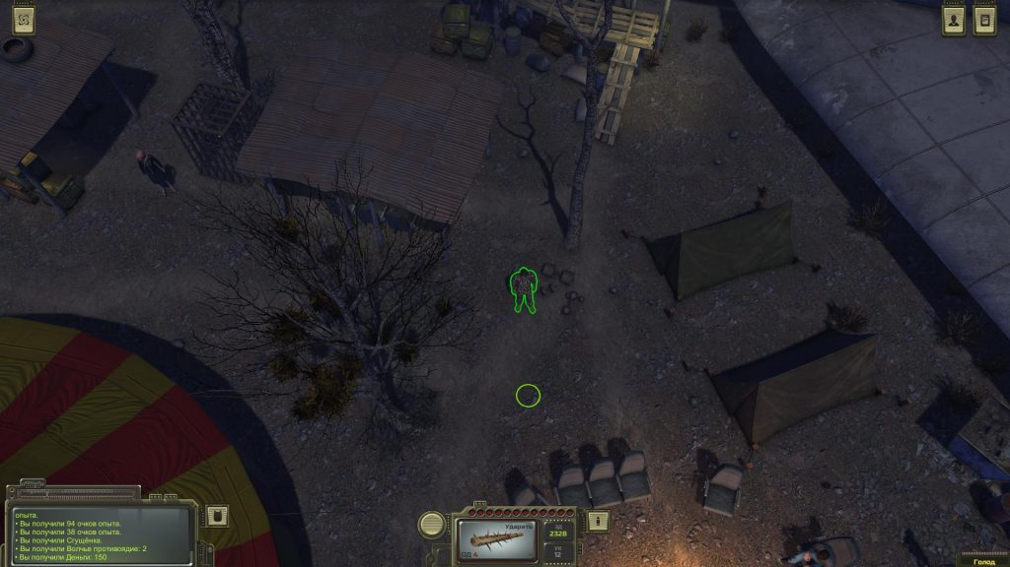
Go back in Krasnoznamenny and talk to the general. He will give you a reward - 252 experience points, 500 rubles and a video cassette with film.

Where to find the shield of Roevsky?
There is a casino next to the brothel, on the right side. Visit it and chat with the bearded man sitting at the bar. Agree to help him.
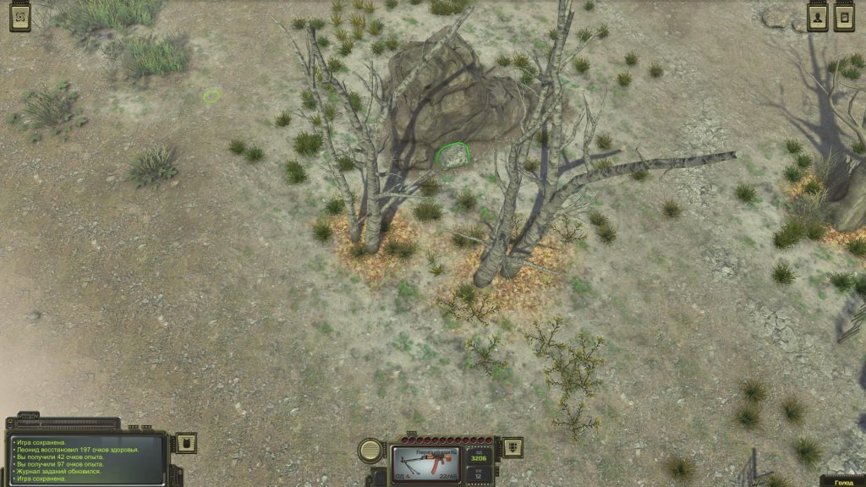
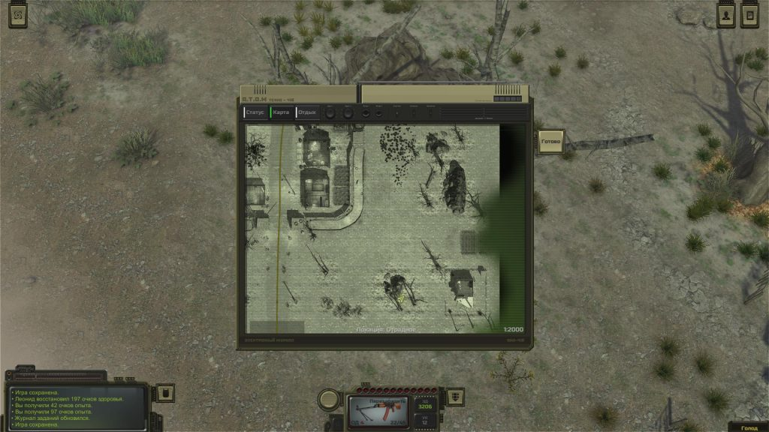
Go to Otradnoe and go to the lonely hut. There is a large rock not far from it. You find a stone under it. Raise this stone with power or other tools to find the first part of the shield. You need to find three more. Also there is a book indicating their location:
- The second part is in a Drunken Lair.
- The third part is in a mysterious cave. You will find it in the north of Krasnoznamenny. Kill four wolves, search the shelter of the person and collect the item.
- The last part is located in the fortress on the right side of the Wastes. You need to kill four enemies, and then take the item.
When you collect all four parts of the shield, then buy or find the glue “Moment” and glue the items through the “Craft” menu. Take the shield to the casino. You will get 200 experience points, 600 rubles, and perk (it gives 6 points of damage resistance).

Help Xander
Opposite the Chamber of Commerce you can meet an unknown man named Xander. He asks you to come between two lovers in the location Circus. Agree to do this.
Go to the circus and go to the fire, around which people are sitting. Try to convince them that their union is wrong, but nothing will come of it. Even if you pass the test of communication, lovers will love themselves even more. We chose this option.
Go back in Krasnoznamenny and report it to Xander. For this you will get some experience points. If you manage to separate the pair, then Xander must pay you. In any case, after that he will disappear.

Attack on the Circus
This task you can take from Gennady Nikolaev under the Chamber of Commerce. You can agree or refuse to implement it. If you agree, but you want to complete other quests related to the circus, then do it first. By the way, it is not necessary to kill everyone, perhaps a peaceful solution.
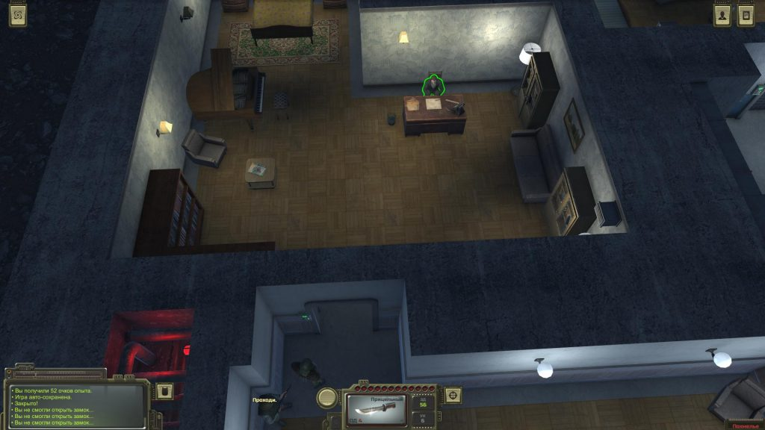
We went to the Circus location and entered the plane and talked to the main old woman in the. They informed about the intentions of the Secretary General, as a result we learned that he was a mutant. Say that you do not kill anyone, and then return in Krasnoznamenny. Talk to the Secretary-General about everything and say that the people in the Circus will be silent if he does not touch them. In addition to 1260 experience points, ask for money and get 3000 rubles from him.

Interview with veterans
Chat with the same journalist Vladislav Zhirenko to get a task from him. He wants you to interview three veterans. You will find the first one north of the hotel. You need old man Ambrose Trufelev. He will be practically naked. Convince him to give an interview or pay 100 rubles. Do not interrupt, listen in silence, and in the end you will get 59-32 experience points.
Sergey Maslov is in the lower part of the city of Krasnoznamenny. It is located in a building in the north. Report that you asked to interview Zhirenko. He will give it for free. If you lie, then you have to pay 100 rubles. Listen to the story of Maslov. If you expose him later, you will earn 50 experience points.
The third veteran - Visotsky is located near the entrance to the bar in Krasnoznamenny, where you took Fidel as your partner. You can meet him at night. He agrees to talk for free. Go back to Zhirenko and get 500 rubles.

Stolen Lenin Statue
There is a statue opposite the Chamber of Commerce. Also, there is a man. This fanatic will tell you about the abduction of the statue of Lenin. It is located on the scrapyard of ironworks. Go there.

Barbecue in Peregon
Next to the cinema is a former postman. Chat with him to get the job, and then go to Peregon. Go to the barbecue left-down from the entrance to the tent city. Talk to everyone; tell the man sitting at the table that he needs to go (call a secret phrase). All leave, and you can enter the container and descend into a secret lair.
Kill the enemy, collect loot, and then try to get out on the stairs. Five or six gangsters will appear, and you will have to fight them. At the end of the battle, collect the loot and return in Krasnoznamenny. Report the postman. For this you get 378 experience points and 1500 rubles.

Cryptocurrency (Crooks)
In the suburbs, there are stalls on the right side of the gate. Go to them in the afternoon and you will see two crooks in a white dress under a tree. There are two deceived customers next to them. Chat with the guy in the dark jacket. Talk to the crooks, use force or charisma to return 1000 rubles. And then decide what to do - return the money to the quest giver or you can keep it.

Arachnid lymph nodes
Take a look at the Hospital in Krasnoznamenny and talk to the doctor. Zinaida will ask you to find 10 arachnid lymph nodes. You will find the mutants on the “Red Fighter” location. Collect items and return to doctor to complete the mission.
Note. This task is best done with the quest described below.

The base in the "Red Fighter"
Look in one of the wards of the hospital so that Fidel meets his friend Gozhin. Chat with him on all topics. He will propose to establish a base on the location "Red Fighter", but first you need to destroy all the mutants.

Eliminate a journalist for Artemyev
If you decide to buy parts for the car from Artemyev on the task of Kovalev, he will offer to perform two of his tasks. One of them is connected with the elimination of a journalist located at “Rest stop 6”.
Follow to location and you will see that the wolves have bitten off the journalist. Return to Artemyev and report him in any format. You will receive 100 rubles.

Find a decoder in the Radio bunker
The second task of Artemyev is connected with the search for a decoder in Radio bunker. Bring with you a gas mask. Go to the location, but the entrance to the bunker is locked. You will need a master key or a high level of hacking. Once inside, kill the rats. Run into the left far room and take the decoder from the shelves. Run outside and use an antidote. Return to Artemyev. You will receive 100 rubles for the task, but if you complete both quests, he will give the carburetor and the starter for free.

Peregon
Go to this location. It is located in the upper left corner of the Wastes. Go to Peregon and talk to the man. You will learn that you need to buy passes in the building on the right. Do it. Go to the entrance to the tent city and chat with a long-haired man. You will learn where to find the leaders of the organized crime group "DEATH" from him.

Lena, Dima and Igor Death (Leaders of an organized criminal group)
Dima Death is located in the eastern part of the map, not far from Bunker 317. Lena Death is hiding in the east of Peregon, and Igor is in the north, above Peregon. Kill them all to complete three separate missions with good loot and experience points. You will find Dima Death next to the bunker.
This task is directly related to the old gangster from Krasnoznamenny, so you will need to go back to him and complete the task.

Get rid of gangs in Peregon
Go to the tent city and climb the barge. Go to the right side and you will find a man in a white suit before entering the barge. He will ask to get rid of gangs and sects around Peregon. Go outside, walk around the city and provoke gangs to attack you. You need to destroy three gangs and then return and complete the quest. We killed three groups of sectarians, but note that many of them use explosives and destroy themselves. Return to the quest giver. As a reward, you will receive 126 experience points and 700 rubles. Use the conviction to get another 150 rubles.

Power Struggle on Peregon
Go to the barge in Peregon and enter the building on the left (before reaching the bar). Chat with Fyodor Maksimovich sitting at the table. Agree to help him. Go down to the lower level of the barge (through the entrance on the right) and go left past the room where dog fights are held. Left, there is the office of Abramov. Talk to Zhenya at the entrance, convince him to let him inside and chat with Abramov. If it is possible to agree with him, he will agree to make Maksimovich a judge.
Go outside and you will see the building to the right of the tent city. Go inside and talk to the guard at the office. Say what Fyodor Maksimovich sent you. Pre-save, because you have to go through the test for charisma in a conversation. Decide what to do: you can to comply with the request of the chief of security and kill Abramov and Maksimovich, or you can try to convince the chief or strangle him. As a reward for completing the quest, you will receive loot, experience points and money depending on the chosen side.
Our choice: the murder of the chief of the guard and the transfer of control to Fyodor Maksimovich.

Illustration for the book of Gubtsov
You will also meet a man sitting in one of the rooms at the bottom of the barge (behind the office of Abramov). Talk to him. He is an artist, and he needs inspiration. There is a certain Patrick in Krasnoznamenny, who can describe the monster "Kukish". Agree to help.
Follow in Krasnoznamenny and talk to Patrick, who sits in the bar of the suburb. Go back to Peregon, talk to the artist and get a reward - 300 rubles and 126 experience points.

Help with wolves
One of the soldiers at the entrance to the tent city will ask for help with the wolves. Agree and kill six or seven predators. A soldier will help you. For this, you get 336 experience points and a few ammo.

Runaway car dealer
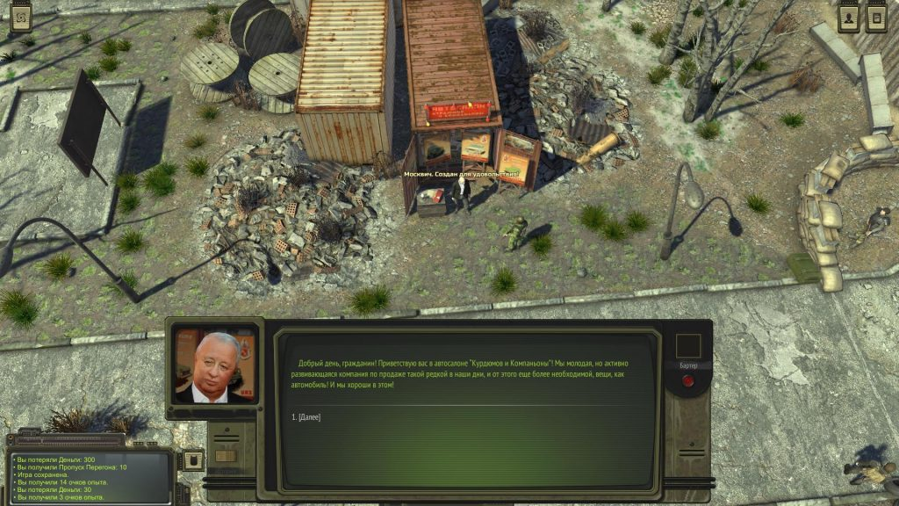
You will meet a man not far from the entrance to the tent city. Talk to him on all topics and order a car. First you need to wait two weeks, then another one, but after it he will run away. If you have done all these actions, then talk to the guard at the entrance to the tent city and find out where the seller has gone. The guard will say that he went to the casino in Krasnoznamenny. We followed him, talked and decided to check out the option in which the main character agrees and gives the seller another 1,000 rubles.

Where to find a new companion (Batori)
When you re-visit Peregon, you will see a girl near the entrance. If you decide to enter into the "Death" group, then she will agree to be in your team. But you have to kill the rest of the companions, and the merchants and neutral characters in different cities will become your enemies.

Red Fighter
Here you will go on several tasks. For example, two of them you can take in Hospital of Krasnoznamenny.

+ Base in Krasnoznamenny (continued)
Go up the map from Krasnoznamenny along the railway tracks. Go past Rest stop 10, but there is nothing interesting there. Climb to the top right corner of the map to find the person in the house. He will open the way inside if you kill the six arachnids. Kill them but do not forget to collect lymph nodes for the doctor.

+ Where to look for a second companion?
When you kill everyone, enter the house and talk to Hexogen. This will be your second companion.
After killing all the mutants, return in Krasnoznamenny and report it to Gozhin.

+ Construction of the base in Krasnoznamenny
In a conversation with Gozhin, you will learn that he will repair the city. Visit the village again and see your house - near the exit. There is Pasha, a local mechanic and builder. If you pay him, he will make any request:
- Drain the water - 500 p. You can do it yourself. Go down to the bunker, repair the pump. When there is no water, you will need to start the generator and turn on the light.
- Remove poisonous mushrooms - 1000 p. Pasha will perform this task in a day.
- Refill all generators with diesel fuel - 5000 p. Need to wait three days. Electricity will appear in the city. You will meet Nicholai next to your house, the manufacturer of ammunition. You can hire him.
- Build a workbench - 2000 p. You need to wait a day. A room with a workbench and other pieces of furniture will appear in the house, and Nikolai will make the ammo.
- Build a rest room - 3000 p. Need to wait one day. A barbell will appear in the house (three workouts per day - a temporary increase in strength by one unit), a radio station - you can receive calls from caravan drivers and meet them near Krasnoznamenny, a closet - we change the main character, two dummies - you can store armor. Also you will see a paratrooper Alexander next to the house. This is your new companion!
- Build a kitchen - 4000 p. Need to wait two days. You can cook food, store items in the refrigerator. You can call Gulchitai to the kitchen, (if you saved her in the fortress), and then you met her in the former Fidel’s bar in Krasnoznamenny. She will cook food.
- Build a bedroom - 3000 p. Need to wait three days. In the bedroom you can not only relax, but also take a shower, which removes radiation.
Dunya and Sasha will come to the location after you will complete the quests at the Abandoned Factory.

Farm "Safe journey"

+ Gunpowder for Alenka
Try to get inside, you will meet Alenka. Talk to the girl and learn about the quarrel with Stepan Balagan. She needs 20 gunpowder. Buy it from caravanters or anywhere else. Give her and you will receive 300 rubles and experience points.
When you bring gunpowder, then if you have found in the house of Alyona’s adoptive father a ticket of an ATOM fighter, then give it to the girl. You will receive an additional reward, and the girl will go in search of information about her real parents.

+ Cheating
Talk with the head of the village; he thinks that his wife is cheating with a certain tourist Korallov. The bedside table is locked at the bottom of the map. Wait for the night until everyone falls asleep, crack the bedside and find a plastic ring. Give it to your husband to get 30 rubles and vegetables. There is another stand in the central part. It is a ticket fighter ATOM, Belous Anatoly Pavlovich. Ask for a ticket from the head of the farm. He found him with his daughter.

+ Kasparamid for Yana
Talk to Yana. She is the wife of the head of the farm. She will ask you to find five packages of Kasparamid. Buy it anywhere, and then give it the woman. You will get 100 rubles.

Abandoned bunker 317
Here you go in search of the expedition of General Morozov.
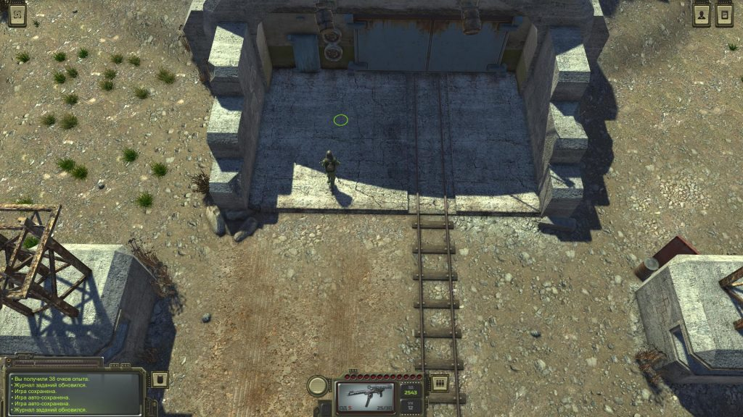

+ Expedition of Morozov (Bunker 317)
Search the corpses near the helicopter to find the diary of Ivan Lenin. You will know the password to the safe - 4316 from it. There is a grave in the southern part of the location. The bunker itself is closed, so go around it in a circle and kill the mutants. There is a camp of bandits in the southwestern part of the map. Three opponents have avatars of famous Soviet characters. Agree to their offer. Gangsters will open the bunker, and you will have to clean it.
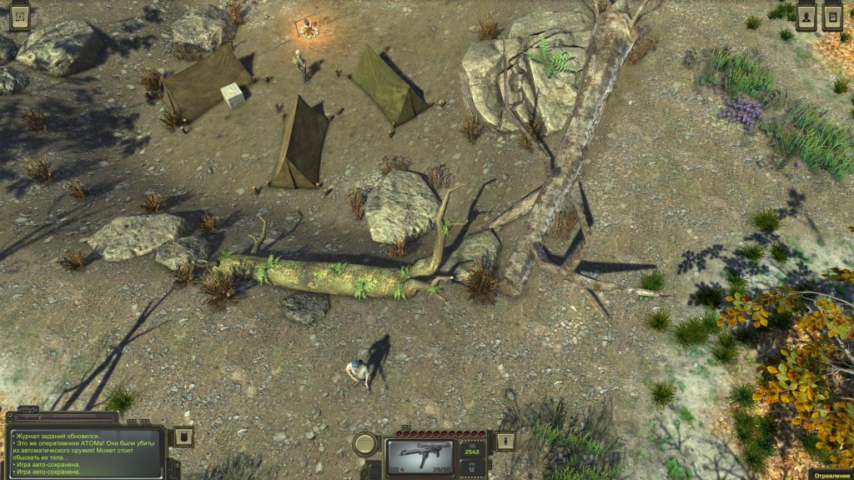
When you get out of it, the bandits attack the main character. Take a backpack from the corpses of enemies. It allows you to carry an additional 28 kg.

+ Ground floor of the bunker
You need a tool box to break into soda machines. Buy tool box from the technician Steblev from Otradnoe. You saved him at the Abandoned Factory.
There is a safe in the room on the right. Enter code 4316. Kill a rat, search the corpse and get the magazine “Youth and Technology”.
Go to the room on the left side of the elevator, interact with the computer itself. Select "Open", read the three letters and learn the code from the rest room - 2104. Collect things, and then select the command on the computer "If the elevator is closed, then open". Get down.

+ Second floor of the bunker
There is a mutant Gavrilov in the southwestern part of the bunker. Chat with him. He asks code from the first door of the laboratory - 4334. Find the commandant’s living room near the cafeteria. Go and take a mysterious book with the password to the safe. As a result, you get the code 9731. Open the safe to get a note with codes and other useful items.
There is a block of scientific personnel in the eastern part of the floor. Go to the first room and you will find a list of codes on the table. Use these codes to enter in other rooms. Pick up different diaries and other items.
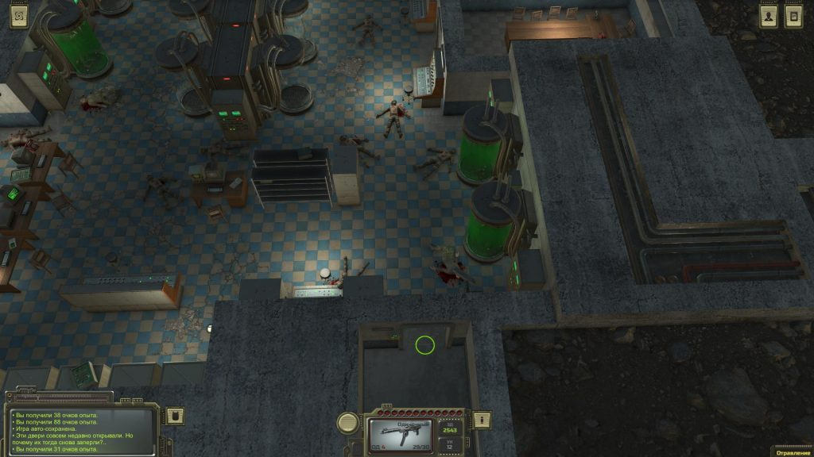
Go north where the labs are. Enter the code that you will learn on the computer of the northern room in the room of the scientific staff, or in conversation with Muravyov. This is code 4334. Look at the corpses and look for the Wastes map, on which Krasnoznamenny is marked. Take away the mysterious talisman. If you have Fidel with you, he will say that he saw similar talismans from Mushroom Cult. Thus, now you need to penetrate the headquarters of the Mushroom.
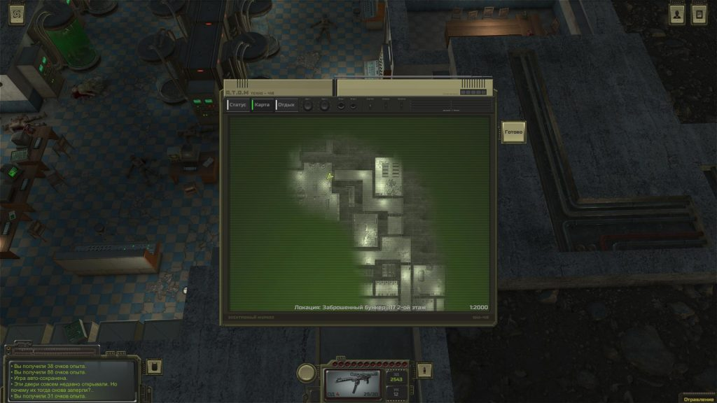
Search the bunker to the end, and then exit. Kill the bandits or convince them to let you go, leave the location. If you kill the bandits, then take the key and open a box in the bandit camp near the bunker.

Fogelevka (How to get to the Mountain Pass Woes)
Visit Fogelevka, located in the lower left of the map, next to a huge lake. Go through the gate and talk with the driver of the ZIL. He agrees for 5,000 rubles to take you to the location Mountain Pass Woes - this is the third global map in the game.

+ Dad's daughter
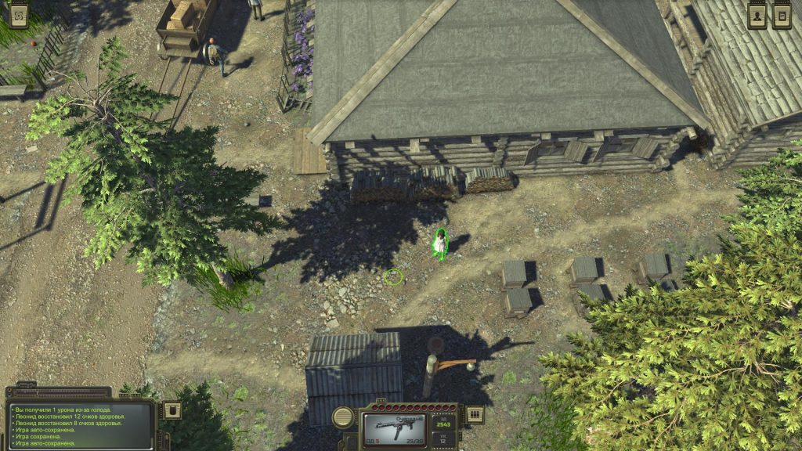
There is a bath in the northern part of the village. There, you will meet Pereslava Garkushkina under the visor. Chat with her. She wants you to convince her father. Dushan will say that he had a dream in which his daughter was taken away from the village. Convince him.

+ Package to Circus
There is a huge house in the western part of the location. Go inside and chat with the postman. He asks to deliver the package to the circus. Give the package to clowns at the circus to get 200 rubles. There are drugs inside.

Scrapyard
+ Statue of Lenin
This task you can take in Krasnoznamenny. Pump the character not lower than the tenth level, so that the quest giver appears on the square. Talk to him, go to the Scrapyard. Storm the scrapyard. Open the gate, kill the enemies on the walls and deal with the remaining enemies below. You can shoot at gas cylinders. When you kill opponents, talk to the commander. Collect loot, return in Krasnoznamenny and talk to the quest giver. You will get the chainsaw “Wrath of Lenin”.
At the same location, there is a garage with a car. If you manage to repair it, you can move around the Wasteland by car. Just like us:
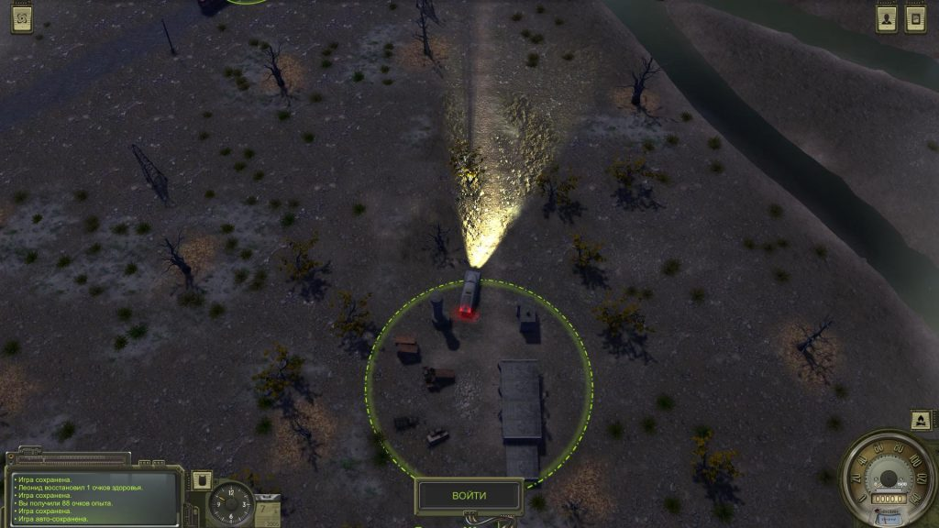

End of the line
Collect the squad to repel the attack of the bandits, and then go to the north from the location “Red Fighter” to find the “End of the line”. You find an enemy camp behind the cars. There will be nine people. Attack them from the left side. Stand next to the sniper Ludmila and shoot from afar. If Luda dies, you get her sniper rifle. Collect rifles from bandits, return to the quest giver in the bar in Krasnoznamenny and complete the quest. You will get 500 rubles.

Mushroom cult
Go in Krasnoznamenny immediately after visiting the bunker 317. You can find the headquarters of the Mushroom Cult in the upper part of the city, in the right side. If you have finished the task of sectarian Igor and got rid of Davi, then go to the suburb of Krasnoznamenny. Description of quests you can look in the section "Krasnoznamenny".
By the way, you need to follow the sect of Davi Chrisht. After you report Igor to the Davi tour, and ask him about membership in the sect. He will send you to headquarters. Talk to the guard to learn about the four principles of the Mushroom Cult. Go inside and chat with Ariadne.
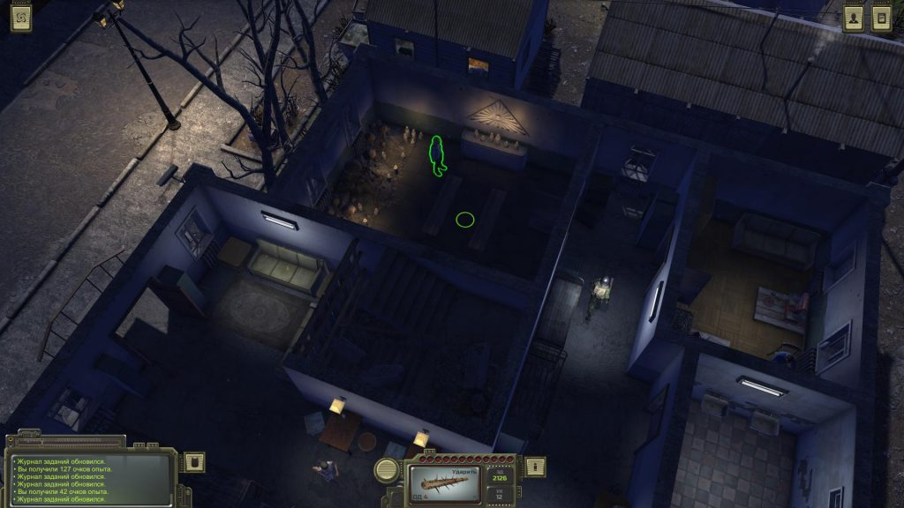
Here are four answers to the questions:
- The principle of modesty. Choose any option because all is wrong. Ariadne will give one day to think. After a day, go back to her and answer "Yes, I think."
- Principle of love. "Yes, all people have the right to have these privileges."
- The principle of unity. “I am ready to embrace all of humanity! All people are related to me. ”
- The principle of death. “Death does not frighten me! I am ready to sacrifice myself.
Also, you will need to make a small contribution - 30 rubles and three canned goods.

Return Egor
You will receive the first task from Ariadne. She will talk about a former cultist who has lost faith. You must return it. Move north and go to the casino in Krasnoznamenny. Use high intelligence, charisma or correctly chosen words. Return to Ariadne to complete the quest. You will get 40 experience points. The next task will send you outside the city.

Death tunnel (search on the filter)
Mushroom cult wants you to find a water filter. He is hidden in a war machine in a place called the “Death Tunnel”. Go west along the coast from Peregon and find yourself at a car tunnel. Go around the lake counterclockwise. At the entrance to the tunnel, examine the car and go to the rooms to the left of the blocked tunnel. Search the stalker's corpse to get a note. There is a code - 9696 on the wall. Enter it and go inside. You will find a way out on the left side.
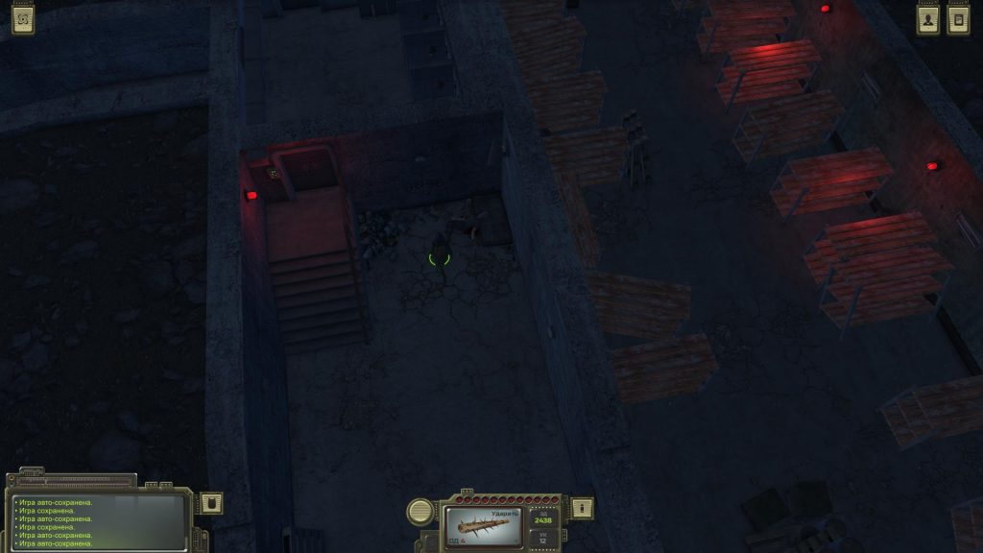
At the very beginning of the location, you will find the turbine (in the room to the left) behind the code door. You need to run it to remove poisoning from the rest of the rooms. If you fail, you will have to get a good gas mask.
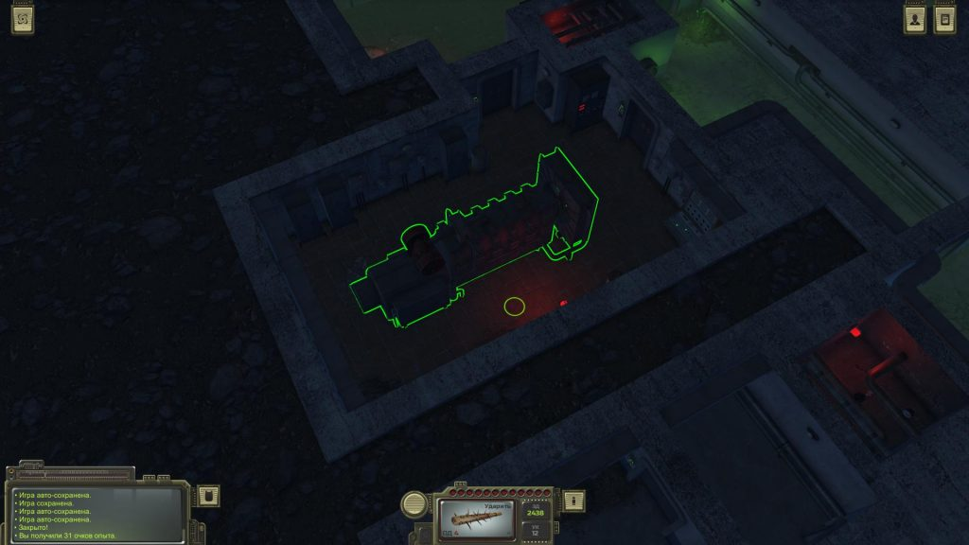
Move deeper into the catacombs, kill small and large rats. You need to go to the lower right part of the tunnel, where there are steps down. So you will reach the specific tunnel where the transport is located.
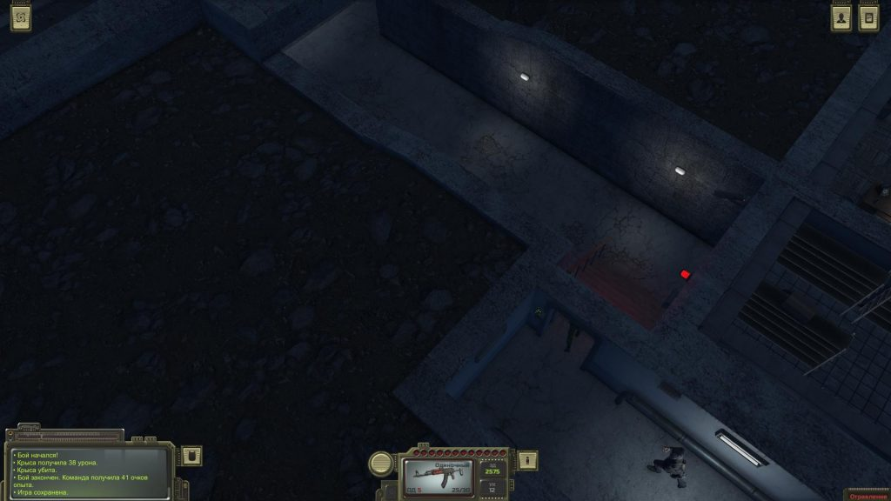
At the end there is a blockage with a cargo military vehicle. Search the boxes on the machine to find the ammo and the water filter. You can continue to study the catacombs, or return in Krasnoznamenny. As a reward, you will receive discounts from the Mushroom Cult trader.
Additionally. The code for starting the generator by the button is white, gray, white, gray, green, white.

Kill the pig
After that, Ariadne will ask to kill the pig of a man from the chamber of commerce. He does not like the cult.
Go to the chamber of commerce and go down the elevator into the bunker. If you have not done this before, you will have to pay the guard money. There is the person with a pig in one of the room. Talk to him. You can tell him the cultists are trying to kill his pig. As a reward, you will receive 700 rubles. But you are about to fail this quest.
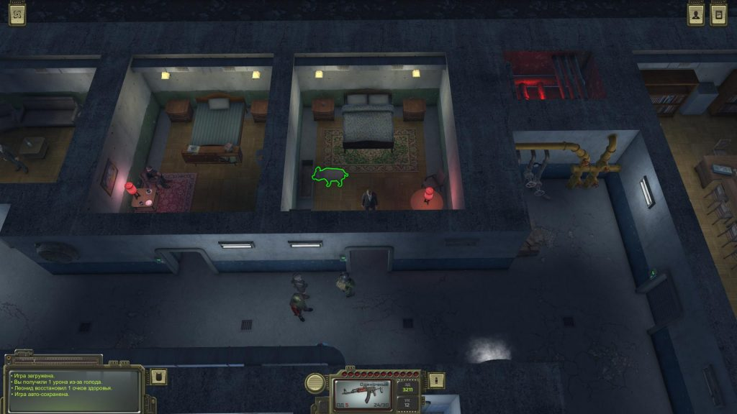
You can try to convince a man through communication. Tell him the general secretary is waiting for him. You can kill the pig immediately via CTRL (with no the alarm). Also you can take a glass jar of potion (in the drawer) and talk to the pig. You kill the pig. Do not forget to leave a note on the body of a pig. If you do not do this, the reward will be worse.
Return to Ariadne and report on the completion of the mission. As a reward, a woman will give you 500 rubles and five first-aid kits. If you can pass the test of communication, then increase the bonus by 200 rubles and two first-aid kits.
Ariadna will send you to explore bunkers in the Dead City and Mountain Pass of Woes.

Mountain Pass of Woes

Caravanserai
You will get to this location with a truck driver from Fogelevka. Please note that there is a guide at the entrance to the local tavern. He is ready to walk you to the Old Castle or Waterfall for 10 rubles.
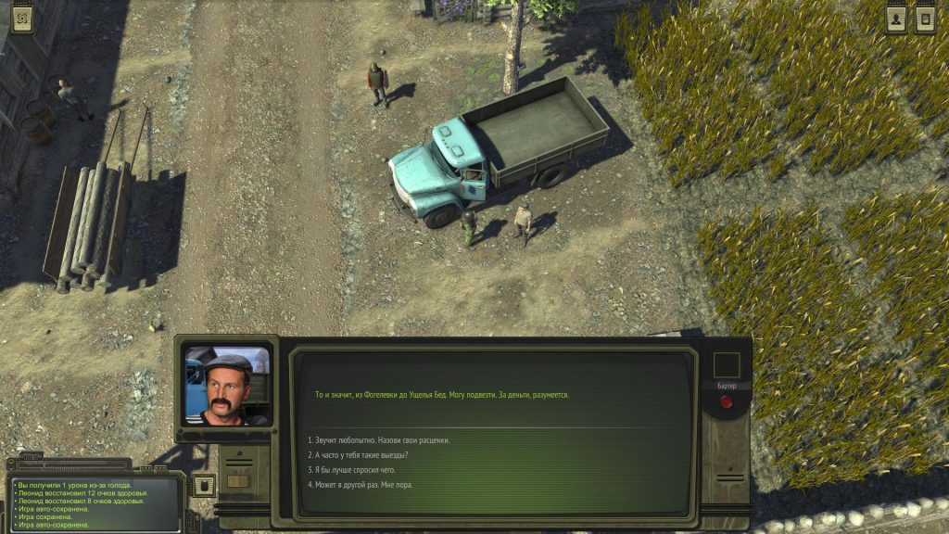

Wolf fangs
You will meet a bald man in the bar of the Caravanserai. He sells ammo. You can also take the quest from him: you need to collect 30 wolf fangs.
We found seven wolves in the lower left corner of the map of the Old Castle. But their health was 111 units each. However it is very easy to collect 30 fangs. You will receive canned food and ammunition as a reward.

Search cook Arsen
In the same tavern, speak with Commandant Mahmudov, who will ask you to find cook Arsen. You can find Arsen on the location "Zagoremskiy Waterfall." Chat with him. He is in love with Alina (the castle owner’s daughter). If you want young people to stay together but return to their homes, then use the option described below in the Missing Daughter. Report to Mahmudov, and you will receive 378 experience points and 300 rubles.

Package Search
The postman from the tavern in the Caravanserai will ask you to find the package. He lost somewhere in the vicinity of the Old Castle. Go to the location of the Old Castle and move around the perimeter to the left. You will find a bonfire and a postman at the top of the map. Chat with him, after which he will give the package. Return to the Caravanserai. You will get 1000 rubles for this quest.

Issues with Artemyev
He will be your bodyguard. There will be a woman there. You can do it in several ways:
- peacefully disperse each one your own way,
- to agree on everything, and then pass a communication test to convince a man to surrender,
- pass the test of attention. If the attribute level is high enough, then you will shoot Artemyev. Otherwise, the battle will begin. If you convince the bandits to surrender, you will get a TT, a “Scorpion” pistol, an F-1 grenade and 189 experience points.
If the woman survived, then talk to her again. She will ask for 1000 rubles to get to Trudograd. You can give money or refuse. We chose the first option.

Old castle

Help a husband addict
Chat with the woman in the fortress. She will ask you to help her husband Azis. Walk to the right and climb to the top of the fortress along the only path. There is Azis inside the tower. Talk to him and convince hum. Return to the woman and get - 333 rubles from her.

Mother's insult
Efendi (in one of the two rooms of the Old Castle) will ask you to talk with Gazi-Mahanmed. Go outside and find Gazi-Mahanmed by the fire. Talk to him and find out that he played a colleague. Return to Efendi and decide what to do. You can lie, as a result of which you earn only a few experience points, or you can tell the truth. Efendi will promise to keep track of his words in the future and gives you many supplies.

Missing daughter
In the next room you can chat with Edward. Ask him for his work, and he will order to find his missing daughter Alina. She is in the vicinity of the Zagoromskiy Waterfall. You will also need to convince her to return home. By the way, you can safely pick up a rifle from the table Edward. He will not do anything to you.
Go to the location in the upper right corner of the map. There, you will find Alina in company with chef Arsen. You can take Alina home by force. Also you can tell her that you will say everything to her father. Return to the Old Castle, talk to Edward. There is only one way to finish the story well: you have to use charisma and convince Edward. If it works out, then you will go to the waterfall and report everything to Alina. Follow back to Edward for the reward. He will give 100 rubles and apples.
Finally, you can now freely visit the old bunker. Otherwise you'd have to fight.

Old bunker in Mountain Pass of Woes
Return to the "Caravanserai" location and talk to the guide. Now he can to walk you to the bunker in Mountain Pass of Woes for 100 rubles. Once in place, go inside the cave to be in the bunker.
Go through several doors, and break the second door. You will find yourself in a round room with a control panel. Go to the Red compartment (to the right of the console) but the way is blocked by a door. You can not open it. Move left until you reach a long corridor with plants and monsters. There are laboratories in one part of the corridor, in the other - living rooms. Inspect the rooms and find a hole in the wall in one of them. However, the passage into the room is blocked by powerful plants. You need a strong herbicide!
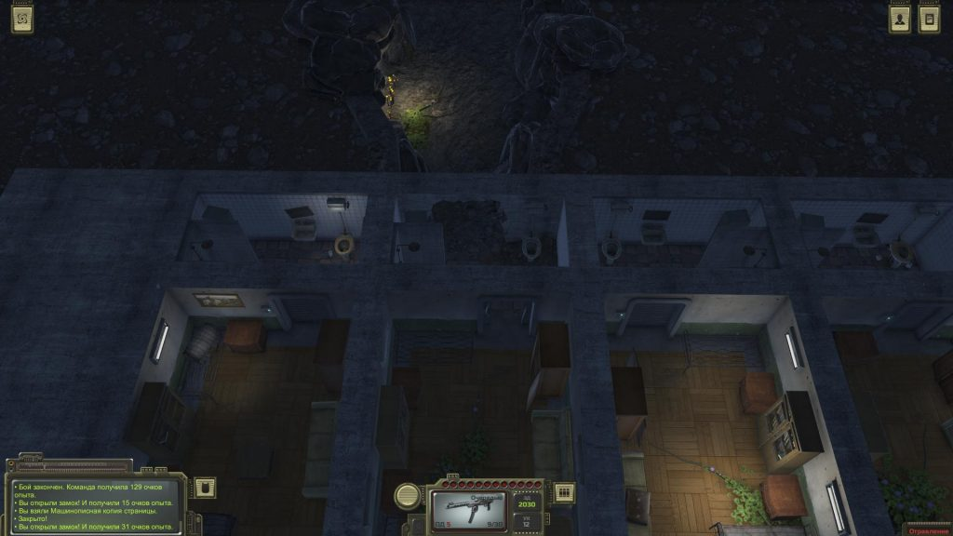
Pass to the left of this room and enter the room with a control panel and a viewing window. There is the test chamber. Use the console; you need to enter three samples. Go left along the corridor with plants and turn into a room with a square flowerbed and yellow mushrooms. Behind it, there is a room with two skeletons and a small shelf. Search the shelf to get a vial of purple liquid (Salvia Sclarea).
Diacetylmorphine powder is hidden in a suitcase (on the sofa to the right of the room with a hole in the wall). We could not find the code from the suitcase, but we can to break it (hold the LMB and select the appropriate action).
The third ingredient - Turbina Corymbosa is located on the shelf of one of the cabinets. In the same place where the remote control is located (to mix the ingredients). This cabinet is open. Interact with a small jar standing on the shelf. This is the difficulty!
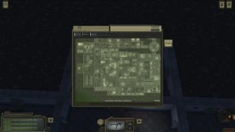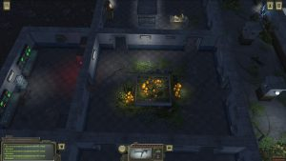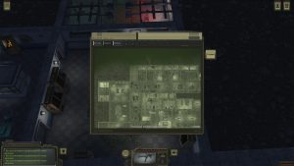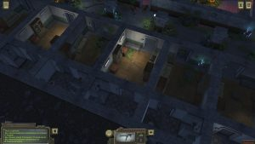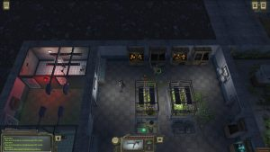
The recipe is located on the skeleton in the corridor nearby. The page is called - “Notebook Sheet”.

Herbicide recipe (how to make a herbicide):
- A portion of Salvia Sclarea - 1 mg.
- A quarter less Turbina Corymbosa - 0.75 mg.
- Two parts of diacetylmorphine - 2 mg.
- Preparation of two phases - first use a centrifuge, and then - dissolving in an alcohol base. Last you need to choose one line!!!
If you do not want to bother, then, lies, find. If you succeed in hacking it, you will immediately.
Note. There is a small safe under the bed in the room next to the closed passage (with the suitcase). Break it to get herbicide spray.
There is an alternative: bring with you explosives. You could have bought it from caravankeepers. So you cab blow up the plants blocking the path.
Destroy the plant and pass into the cave. Kill enemies until. Move until you get the Red Wing. Open the door to the left and find Leopold. He is one of the ATOM man. Talk to him and decide what to do. We had made it peacefully. Open the door behind a group of soldiers and meet the "Mushroom." Talk to him. A strange creature owns the man’s mind. Decide what to do:
- if you let the creature with the ATOM get away - you will receive a note with the “Mushroom” code (8887). So, you can get into the basement under the house of cult.
- if you refuse - you will have to kill all the soldiers.
A door on the right leads to a locked passage and head hub. Nearby there is a room with a computer. Interact with it and enter the code "If the gateway is closed, then open."
Go back in Krasnoznammeny and talk to Ariadne. Report her (what you saw). If you allowed the mutant to leave with a group of people, you will receive a reward - 3000 rubles and different ammo.
You can enter the code in the den of the cultists to open the first door on the way to the elevator. Unfortunately, the code does not fit the second door. So you need to go in search of a second bunker.
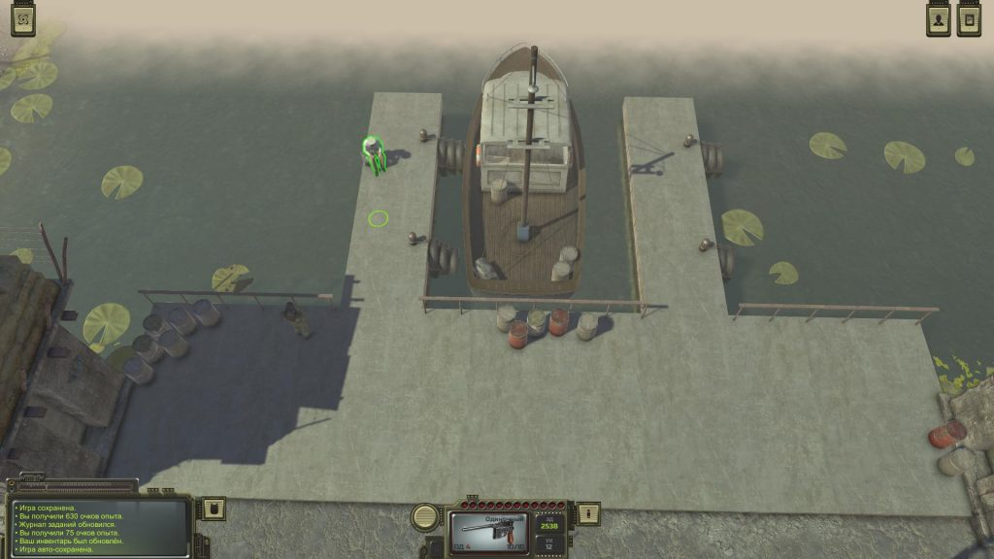
You can get here with the help of the captain of the ship (in Krasnoznamenny). You have to pay 7,000 rubles. If you can bargain, the amount will drop to 5,000.

Gang of Guvner
Go in the Dead City. Chat with a stalker nicknamed Kust in a small camp on the pier. He sits by the fire. He will ask to deal with the gang of Guvner. Agree to help. Move along the lower boundary of the city. Go to the ruins of the institute. A random event associated with the gang should appear. You need to kill seven enemies, each with 140 health points. The task is not easy. Go back to the Kust and you will get three canned goods, 370 experience points and 1000 rubles.

Help Dubravin
Go on on the basis of stalkers (on global map to the top of the city). The merchant Dubravin can give you a task. He will tell that his friend Misha Altayskiy opened fire on him. Need to know what's wrong. Go to the pier, talk to a stalker in a red helmet. Really, he shot the monster behind Dubravin.
Go back to Dubravin and talk about everything. Tell the truth, you complete the task. You get 378 experience points, 1,500 rubles and Sonya's eye. The last item belonged to the thief Sonya.

Grave of Sonya
You have Sonya’s eye. Go to the right lane from the building, where Dubravin is based, and find a lone grave. Interact with her, inspect. Use a shovel and dig up the grave and place in the eye in coffin. Go back to Dubravin and tell about everything. You will receive 126 experience points
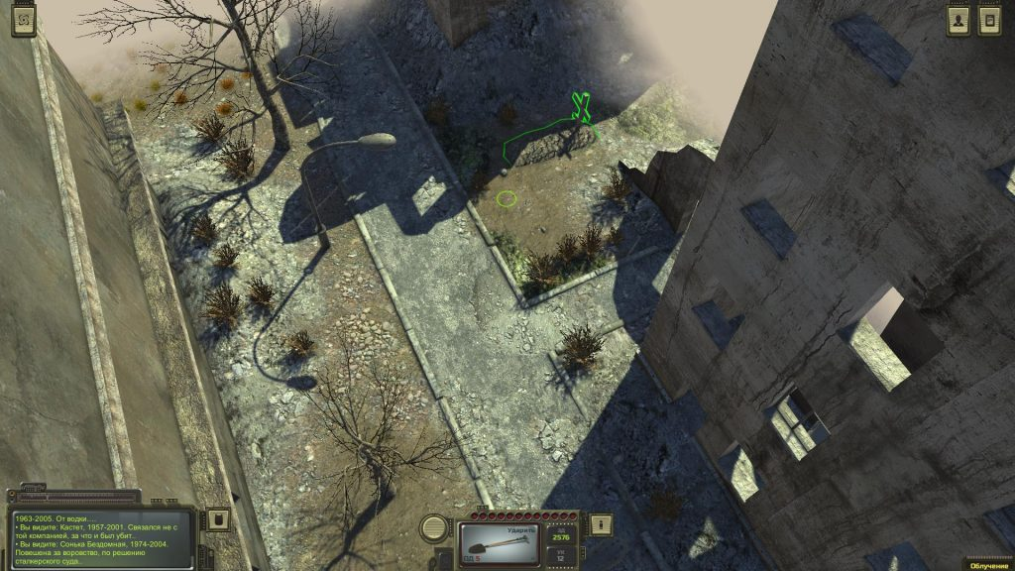

The ruins of the Institute (pre-war bunker)
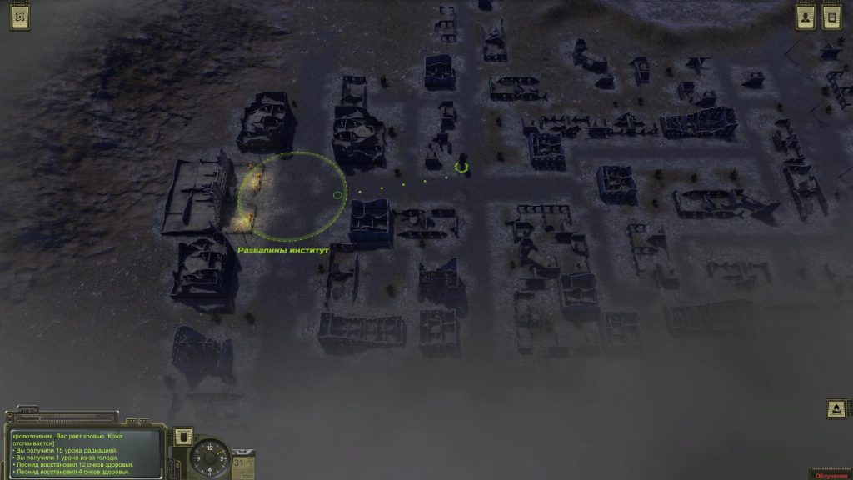
Go to the left part of the city and visit the ruins of the institute. Kill a lot of monsters. The road inside is blocked, but there is a small column on the left. There are ventilation grilles. Study it. You will need a grate to go down into the bunker. As soon as you get it, go back here and get down.
First, go to the left side, in rooms with elevator doors and a lot of rats. Kill all the rats, break the suitcase on the floor, read the note and study the photo. Take a white plastic card from the skeleton at the elevator. Go back and go in the other direction.
The way forward blocks the door with a red lamp. Examine it and find the artificial intelligence. Choose the following options (they will be available only if you studied the photo and note; you need a note from the control panel to the left of this door):
- Stanislav Petrovich.
- Turgenev.
- Professor.
- I was a scientific engineer.
- Married to Galina.
Access is open. Go down the hall to the right and find another door with artificial intelligence. This time you need to pretend to be another person. Go back and go to the room on the left, where there is a note on the table with the code from the locker - 9999. In the room opposite, there is a note with the results of the analysis on the shelf. Go down the corridor and take a look at the office with the skeleton on the left. There is a note on the table. It addressed to Natalia Borisovna.
There is another note on the billiard table in the recreation room. There are lockers in the same room. Inside, you will find the machete.
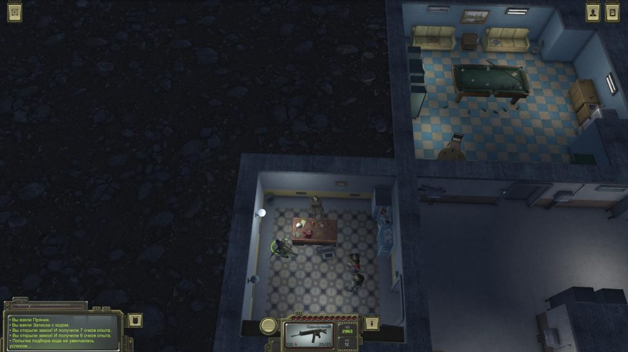
There are three tables with computers in the room next to the general's office. Also, there is small shelving. Search to find a crumpled note. Return to the general's office and remove the award certificate from the wall. Examine it in inventory, then interact with the door and answer the questions:
- Victor Andreevich.
- Ivolgin.
- My rank - General.
- Would show you a premium pistol...
Go to the next door. It will be necessary to pass the test of communication with the use of lies. If it works, then you can go further. Otherwise, you will have to go to the room with the robot and destroy it. After destruction, interact with the cabinet in the corner and enter the sequence 0010.
Go through the door and chat with another squad. You can kill them all or let them take the samples. Anyway, you will receive a note with the second code of the Mushroom Cult.
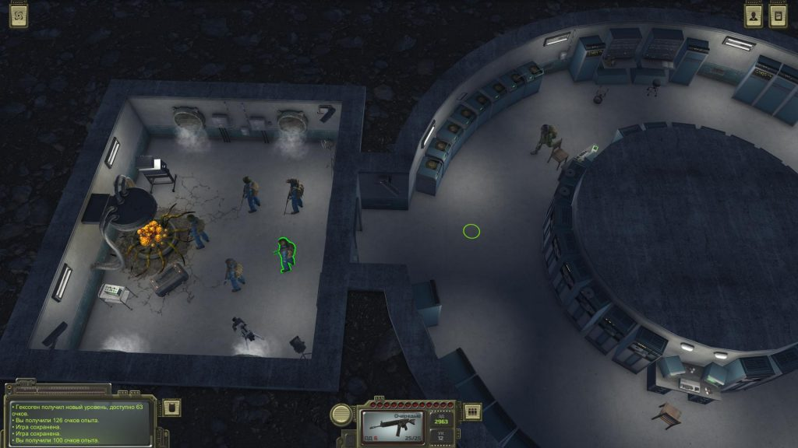

Mushroom Bunker
Return in Krasnoznamenny and go to the headquarters of the Mushroom Bunker. You will find here the military from the ATOM. Talk about everything. You can ask the military to escort you to the bunker, or tell them to disperse. We chose the latter option. Go inside and use two notes with cipher. You open the doors leading to the elevator. Go down on to the Mushroom Bunker

Endings in ATOM RPG
Kill the enemies blocking the path. Go to the elevator shaft and go down using the rope. You will reach the room where the Unification ceremony takes place. Meet a reasonable mushroom in the head of General Morozov. Now, you will have to make an important decision.
If you agree with a reasonable mushroom, you will have to kill Fidel. If you refuse, you will have to kill all the cultists. Finally, if you have enough strength or level of communication, then you can completely convince a reasonable mushroom to perform a unity ritual. In the case of communication, you will need to choose the second, and then the third.
Go to the green area to leave the bunker and watch the final video.

